Meeting Notes

***Meeting Agenda*** –Meeting to build circuit and complete mechanical work in Makerspace.

***Meeting Attendance:***

Balaji Radhakrishnan (u7322353)

Bhargav Ashok (u7172176)

The other team member’s presence was not necessary since the physical circuit is being developed by the electrical team.

|  |  |
| --- | --- |
| ***Meeting Notes:*** | ***Meeting Duration ~ 120 minutes*** |

The agenda for the meeting was to connect the Mosfet and Diode to the heat sink. Additionally, the heat sink (aluminium plate) also needed to be attached to the copper clad board. Used to drill in the copper clad board and aluminium plate and with the help of screws was able to make the connection between the various components. For reference we used the following image to help build our circuit.

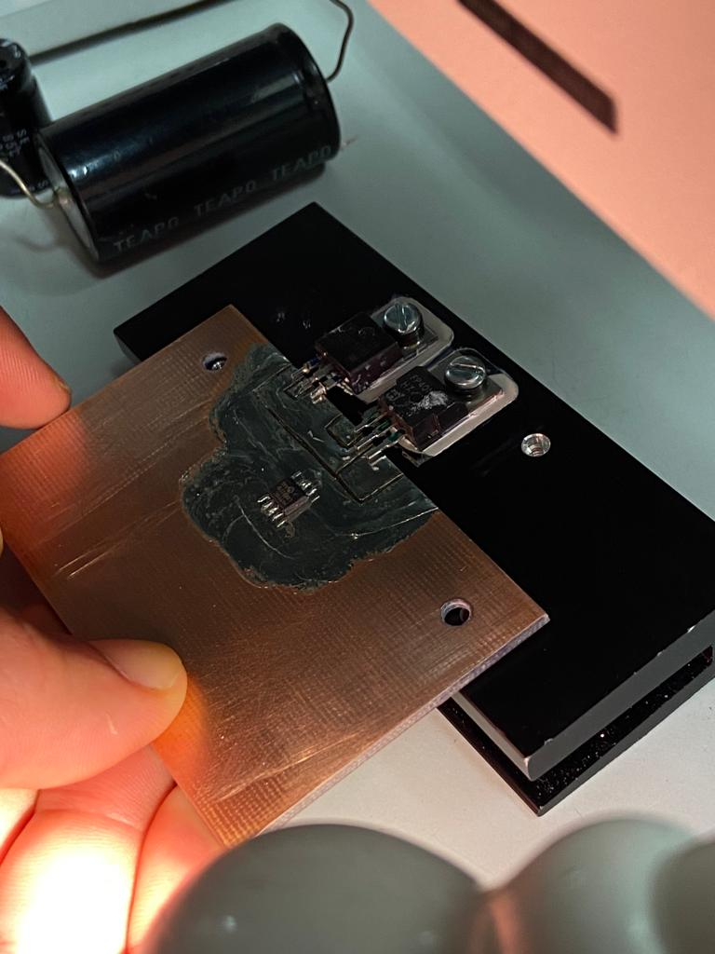

***Meeting Outcomes:***

1. Completed the mechanical work associated with the prototype and attached the Mosfet, Diode and aluminum board to the copper clad board

***Current Deliverables1:***

Complete electrical work associated with circuit and begin soldering the components